Teaming Time
1/7/14

Reports-NeSA & MAPS
NeSA-eDirect
create a chart with indicators tested-high & low/green color box
Lenny has chart/one for reading, math, science
*Student School Roster/individual looks & district look
Get all years to see growth

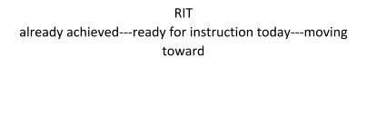
Maps
~class by RIT
~class by indicator
~class roster

Goal: Improve Quality Instruction
Why are we doing this?
Are we seeing the results we want?

Curriculum maps are being completed
Examples: Sue, Lacey

-Monday, Jan. 6
-worked on Self-Assessment Workbook
I took staff responses and averaged them together to us the ratings for AdvancED.
Dr. Moody split the staff into teams-
each team assigned a standard (teams of 6-7)
Hashed out each indicator-decided if agreed w/ staff rating
Then used butcher paper to lay out strengths (3-4), weaknesses (1-2), and how we plan to carry through and continue strong.

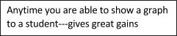
Logins to all teachers---Data breakdown to teacher
NWEA data: class by indicator, class roster
NsEA data: Lenny V. has gotten us started well!
Taking HiLo indicator spreadsheet
2013 marked, need to do 2012-2010

